

Week Report – Week 3

Student: Fatima Hajji
Email:
- fatima.hajji@student.vives.be
- Fatima.HAJJI-EXT@um6p.ma
Phone: +212709173444

Host Institution: International Water Research Institute (IWRI),
Mohammed VI Polytechnic University (UM6P)
Address: Benguerir, Morocco

Local Supervisors:
Prof. Dr. Yassin Ait Brahim
Prof. Dr. Ismail Karaoui
Dr. Athmane Khettouch

Academic Supervisor (VIVES):
Dr. Andy Louwyck

Date: 20/02/2026

- Meeting Summary
Date: 16/02/2026
Attendees:
- Prof. Dr. Ismail Karaoui: Ismail.KARAOUI@um6p.ma
- Dr. Athmane Khettouch: Athmane.KHETTOUCH-EXT@um6p.ma
- Dr. Moad Abbad: Mouad.ABBAD@um6p.ma
- Dr. Sabir Oussaoui: Sabir.OUSSAOUI@um6p.ma

This week started with a methodological refinement meeting in which the conceptual framework of the project was clarified and further structured. The study area was confirmed as the Drâa Valley oasis system, characterized by semi-arid climatic conditions and a strong dependence on groundwater and irrigation.
The main outcome of the meeting was the integration of remote sensing–derived vegetation indicators into the hydroclimatic analysis. The project will now follow an integrated approach in which hydroclimatic variables (precipitation, evapotranspiration, and temperature) influence the surface water balance and consequently affect vegetation response (NDVI) and overall oasis system behaviour.
This approach allows the project to move beyond purely climatic analysis toward understanding how vegetation responds to hydroclimatic variability and how this response may reflect potential water stress and groundwater dependency.

NDVI (Normalized Difference Vegetation Index) was introduced as a key variable. NDVI is calculated from satellite imagery and serves as an indicator of vegetation greenness and photosynthetic activity. In arid environments such as the Drâa Valley, vegetation condition is strongly influenced by water availability. Although the broader objective remains linked to groundwater processes, NDVI was selected as the primary target variable because it is directly observable, consistently available, and suitable for time-series modelling. It acts as a measurable proxy for vegetation response to water stress.

The discussion also covered satellite platform selection (Landsat vs Sentinel-2), spatial resolution considerations for fragmented oasis landscapes, and the use of ERA5 reanalysis data for hydroclimatic variables.

- Practical Work: Google Earth Engine (GEE)
Following the meeting, significant time was dedicated to exploring and learning Google Earth Engine. This included:
- Uploading and managing the shapefile of the study area
- Understanding image collections and filtering
- Applying spatial clipping operations
- Implementing cloud filtering for satellite imagery

Sentinel-2 surface reflectance data were selected for initial testing due to their higher spatial resolution (10 m), which is suitable for heterogeneous oasis systems. NDVI was computed using the standard spectral formula and first visualized seasonally to observe general vegetation patterns.

The workflow was then refined to generate monthly aggregated NDVI time series. Initially, a single year (2022) was processed to validate the method. After verification, the analysis was extended to the full 2018–2023 period, resulting in a consistent six-year monthly NDVI dataset aggregated over the study polygon.
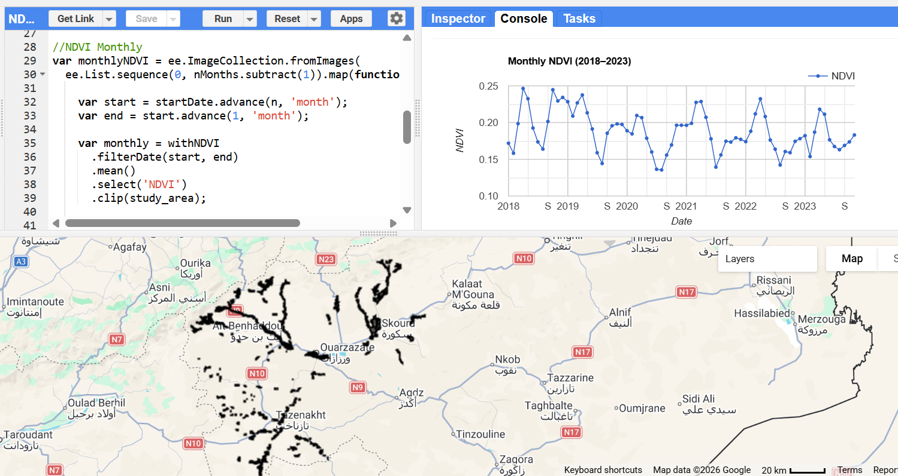
Figure 1. https://code.earthengine.google.com/

- ERA5 Hydroclimatic Data Extraction
In parallel, ERA5-Land reanalysis data were extracted over the same study area and temporal range (2018–2023). The selected variables include precipitation, evapotranspiration, and temperature.
Monthly aggregation was implemented with appropriate physical interpretation: precipitation and evapotranspiration were summed to represent monthly totals, while temperature was averaged. The datasets were exported as structured CSV files to ensure consistency with the NDVI time series.
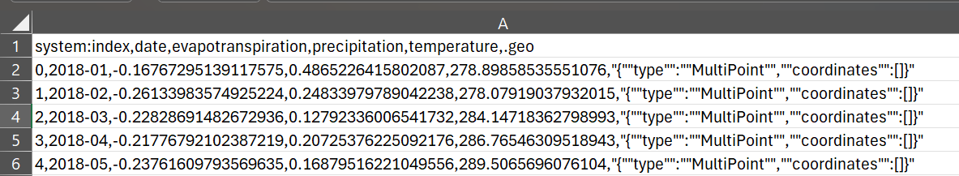
Figure 2. ERA5_monthly_2018_2023.csv

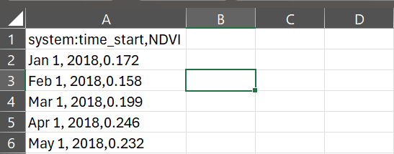

Figure 3. NDVI_monthly_2018_2023.csv

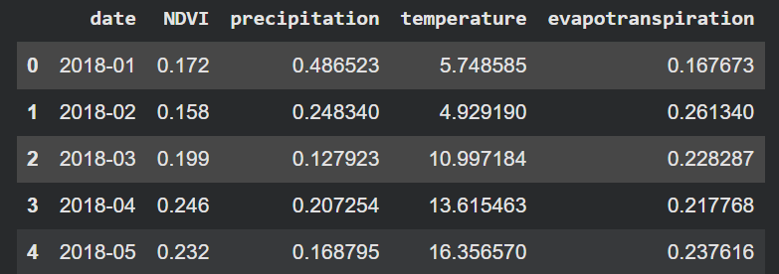
Figure 4. Merged cleaned dataset in google colab
ERA5 temperature values were originally provided in Kelvin and were converted to degrees Celsius for interpretation. Evapotranspiration values, which are reported as negative fluxes in ERA5, were adjusted to positive values to represent water loss more intuitively.

4. Current Status and Next Steps
At this stage, monthly NDVI and ERA5 hydroclimatic datasets (2018–2023) have been successfully generated, merged and prepared for further analysis. The updated hydroclimate–vegetation framework has now been translated into a structured and consistent dataset.
Next week, the focus will be on exploratory data analysis. We will first perform correlation analysis to better understand the physical relationships between climate variables and vegetation response. This step is important to interpret system behaviour before applying machine learning models. After evaluating correlations and possible lag effects, regression-based models will be implemented and assessed.

